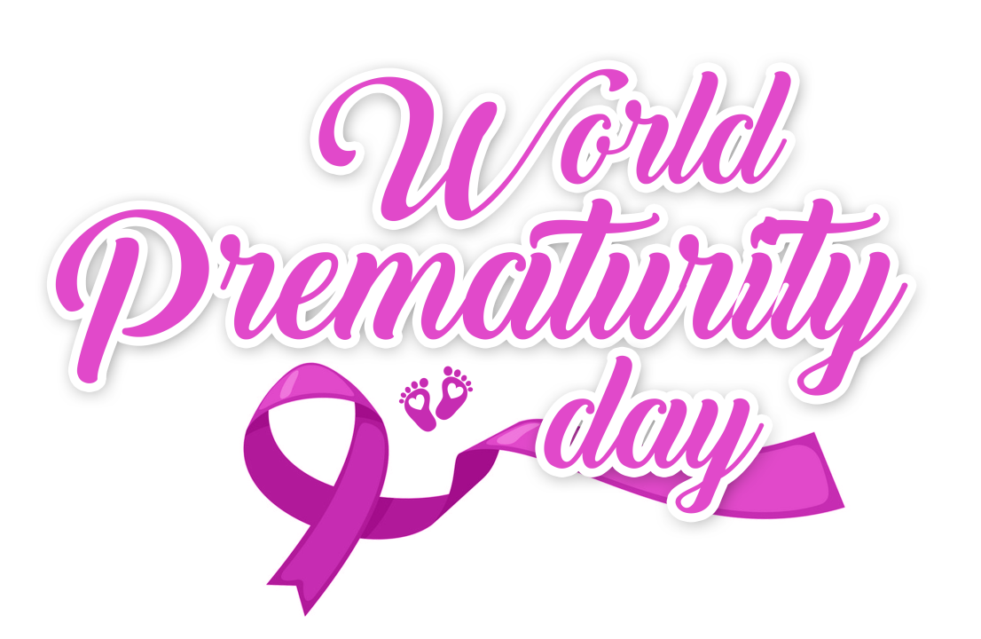

**2019 World Prematurity Day**

In celebration of this wonderful, World-Wide event, the Neonatal Intensive Care Department's, the Medical and Nursing Team members have prepared three (3) separate events and activities for both healthcare workers and families.

* ***2019 Preemie Night Presentation***

***14 November 2019, 6:00PM – 8:00PM***

Will be attended by NICU Gradates and their families.

* ***2019 World Prematurity Day – Scientific Forum***

***17 November 2019, 9:00AM – 12:30PM***

The program is accredited with CME hours. Onsite registration only.

* ***2019 World Prematurity Day – Mini Marathon***

***23 November 2019, 06:30 AM – 10:00AM***

All NGHA employees and their dependents are welcome to join.

To Register, go to <https://www.surveymonkey.com/r/2019WPMarathon>

Registration Deadline: 18 November 2019

For any inquiries, you may email [nic-kasch@ngha.med.sa](mailto:nic-kasch@ngha.med.sa)